UNIVERSITY OF ILLINOIS AT URBANA-CHAMPAIGN



**TSA/KAGGLE PASSENGER SCREENING ALGORITHM CHALLENGE**

**PROJECT REPORT**

**NAME                                                                           NetID**

        Veeraj Gadda                                                 gadda2

        Alexander Marunycz                                      marunyc2

        Siddharth Bhaduri                                        sbhadur2

        Yang ‘Bill’ Xing                                                         yxing10

        Tanmaysingh Rajput                                                 rajput2

**Under the guidance of**

**Dr. Justin Sirignano**

Assistant Professor,

Department of Industrial Engineering,

University of Illinois at Urbana-Champaign

***Master of Science***

***in***

**FINANCIAL ENGINEERING**

**2016-2017**

**UNIVERSITY OF ILLINOIS AT URBANA-CHAMPAIGN**

**DEPARTMENT OF INDUSTRIAL ENGINEERING**

**DEPARTMENT OF FINANCE**

**Abstract**

The Transportation Security Administration(TSA) is currently experiencing high false alarm rates during airport checkpoint screening for passengers, which initiates processes that slows down the entire passenger checkpoint process for all involved. With the number of passengers travelling by air and the number of threats posed to them both increasing every year, the TSA has a demand for improved prediction models to more accurately assess possible threats entering their screening devices. Our strategy for solving this problem is to build upon the knowledge we have gained in this course to utilize convolutional neural networks in three dimensions. We will use this CNN to train a prediction algorithm to identify threats within the training dataset so as to submit our predictions on a test set via the competition website. Firstly, we develop code that extracts and differentiates each threat zone from 16 angles for each test subject. We do this so as to isolate the issue of whether or not there is a threat in any specific one of the threat zones, separately. In the end, for every subject we will have to use the 16 scans to define 17 threat zones per body and then return a probability per threat zone as to whether it contains an actual threat. The log loss of our 17 predictions per subject is the evaluation method for this challenge.

**Chapter 1**

**Introduction**

**1.1 Motivation**

The TSA is responsible for all U.S airport security, screening more than two million passengers daily. As a part of their Apex Screening at Speed program, the DHS has identified high false positive alarm rates as creating significant bottlenecks at the airport checkpoints. Whenever TSA’s sensors and algorithms predict a potential threat, TSA staff needs to engage in a secondary, manual screening process that slows everything down. And as the number of travelers increase every year and new threats develop, their prediction algorithms needs to continually improve to meet the increased demand. Currently TSA purchases updated algorithms exclusively from manufacturers of the scanning equipment used and these algorithms are proprietary, expensive and are often released in long cycles. With airport security a critical and necessary requirement for safe travel and to ensure that this process is fast and has less false rates, TSA has put forth a challenge on Kaggle and we pursue it to use our knowledge of convolutional neural networks to train a prediction algorithm to identify the threats within the training and test datasets. Even an achievement of a modest decrease in false alarms will help TSA significantly improve the passenger experience while maintaining high levels of security.

**1.2 Problem description**

The aim is to create a predictive algorithm that will help improve the accuracy of threat detection and decrease the false positive rates when it comes to discovering threats hidden on a person undergoing TSA screening. The datasets have been provided by the DHS, which contain images of people of different genders, body types, wearing different clothing, and containing various threats hidden on their person. For every scan in the dataset, we will be predicting the probability that a threat is present in each of 17 body zones. The diagram for the body zone mapping is as shown below:

Figure 1: Threat Zone Mapping

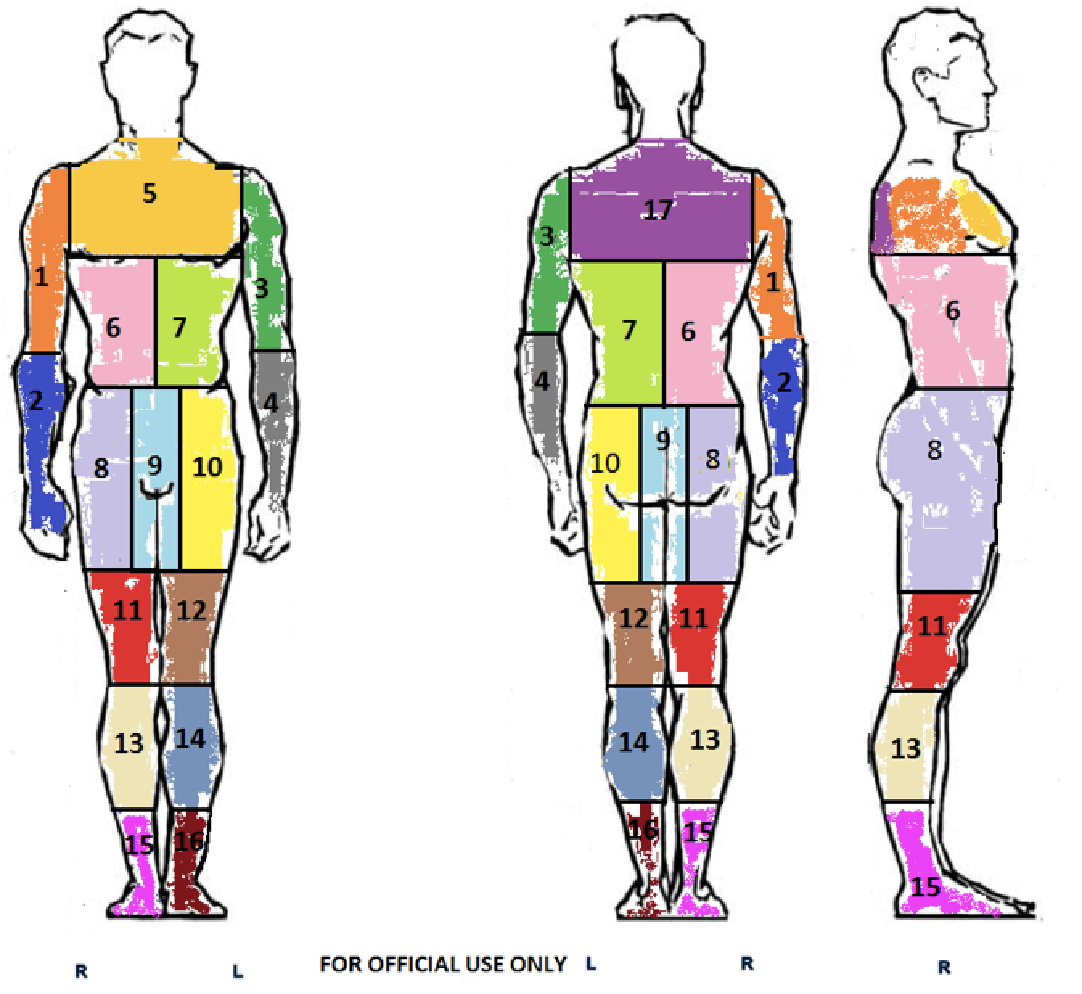

**The following is the evaluation criteria that we must meet, set forth by the challenge provided by Kaggle:**

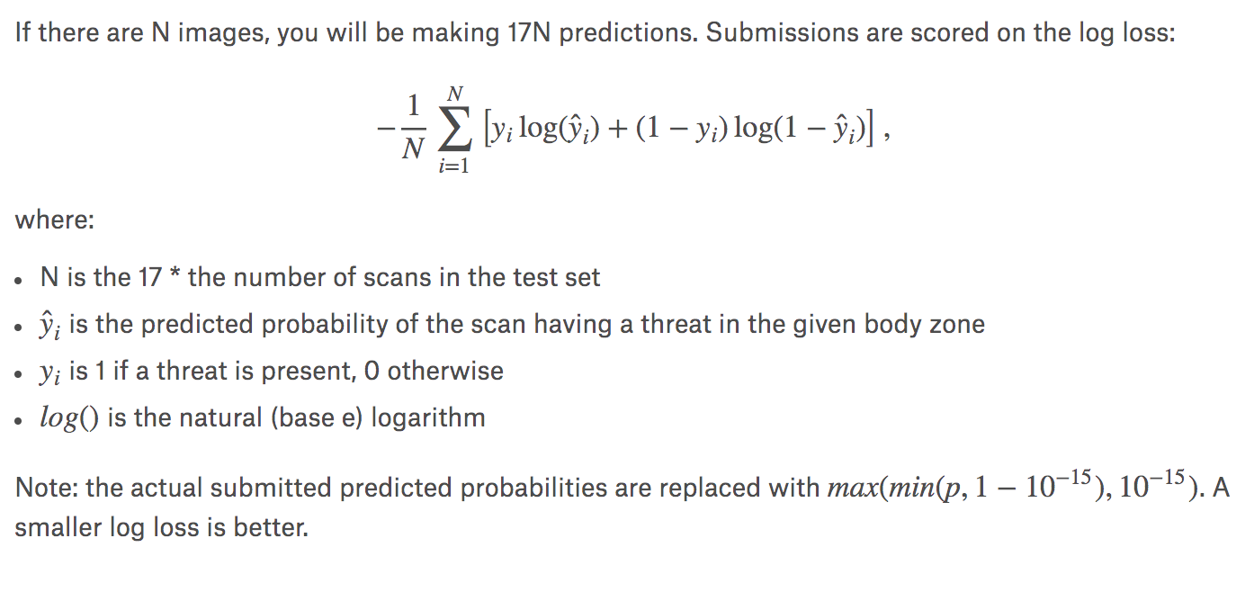

So, we have to predict how probable it is that a threat exists for each body zone per subject ID.

**1.3 Overview of the Report**

* Chapter 1 introduces the motivation for the problem and describes what we shall do with it. It also describes what we are trying to find.
* Description of the methodology used, and how we implemented the prediction algorithms is explained in detail in chapter 2.
* Chapter 3 discusses the results that were obtained.
* The conclusion explaining the whole project briefly is stated in chapter 4.

**Chapter 2**

**Methodology**

**2.1 Description**

For this project, the files that were used were High Definition-Advanced Imaging Technology (HD-AIT) system files. Their size ranged from 10MB to over 2GB per subject. With 1,200 examples, we first needed to find a way to substantially reduce the size of the 512x660x16 image data to be fed into the machine learning model. This reduction in dimensionality would prove to be one of the most crucial and interesting aspects of our project.

**Dataset Information**

The dataset contains a large number of body scans acquired by a new generation of millimeter wave scanner called the High Definition-Advanced Imaging Technology (HD-AIT) system. The Kaggle competition task set forth by the TSA is to predict the probability that a given body zone has a threat present. The images in the dataset are designed to capture real scanning conditions that one would find at an airport. They are comprised of volunteers wearing different clothing types, different body mass indices, different genders, different numbers of threats, and different types of threats.

**Image File Descriptions**

The data for each scan performed by the HD-AIT system is referred to as an HD-AIT Frame. A frame consists of the following four binary files:

.ahi = calibrated object raw data file

.aps = projected image angle sequence file

.a3d = combined image 3D file

.a3daps= combined image angle sequence file

The detailed description of each file is below:

**Projected Image Angle Sequence File (.aps)**

This ‘Projected Image’ algorithm calculates 3D images for 90-degree segments of the data that are equally spaced around the region that is being scanned. A maximum value projection of each of the algorithm’s calculations is placed iteratively into one file. The result of this is an image file that, when played back to back, looks like the object rendered is spinning around.

**Combined Image 3D File (.aps)**

The ‘Combined Image’ algorithms calculates eight 3D images that are equally spaced around the object being scanned, and then adds all of these images into a single composite 3D volumetric image. This calculation is written into the .a3d file.

**Combined Image Angle Sequence File (.a3daps)**

So as to provide some visualization ability, an 'Angle Sequence File' is rendered from the previously described 'Combined Image 3D' data. A projection through the 3D data at iterative angular increments is written into a single file. Similar to the 'Projected Image Angle Sequence' file, the result of this is an image file that, when played back to back, looks like the object is spinning on the screen.  In the end, the 'Combined Image Angle Sequence' file is a series of 2D mm wave images that are equally spaced in changing angles around the object.

**Calibrated Object Raw Data File (.ahi**)

The three other types of images (.aps, .a3d, .a3daps) are processed projections based on the raw data file.

**File Descriptions:**

Every scan in the dataset will have a unique ID. Every ID will have four associated image files, grouped into folders by their associated type.

* Stage1_labels.csv - gives the labels for the training images in stage 1.
* sample.tar.gz - a file containing samples of the image formats.
* stage1_aps.tar.gz - the complete set of stage 1 .aps images.
* stage1_a3daps.tar.gz - the complete set of stage 1 .a3daps images.

**Implementation:**

**Analyzing Individual Threat Zones**

Before we can attempt to build a convolutional neural network (CNN) over these arrays of TSA scanning images, we first must address what in many ways is our biggest hurdle. The main challenge of this entire project is not to use machine learning image recognition techniques to differentiate between scans that do or do not contain a threat somewhere on the entire subject’s body. The true difficulty and precision found within this challenge is to predict not only whether there is a threat present, but whether there is a threat present within 17 different zones on a subject’s body.

It is because this is specifically what the TSA desires, and because this is a critical component of the evaluation criteria for this challenge that we decided to train predictive CNN models for each individual threat zone. That means that for each of the 17 threat zones differentiated on the body, from the different parts of the arms, legs, chest, and so on, we developed a CNN model for each one individually.

To do this, we needed to find a way to segment each image scan in a way that only one individual threat zone was present at a time. Not only would this serve to build 17 different prediction models, but this also reduced the dimensionality of any given image being trained upon. The successful implementation of differentiating the various body parts, and thus, threat zones, was integral to condensing our computation time. In the end, we were able to train a CNN model on a given threat zone for about an hour’s worth of computation time. So, for all 17 models, it took approximately 17 hours of computation time.

**Differentiating the Threat Zones from within the Scans**

So exactly how we were able to distinguish each body part’s threat zone in order to train a model for each one individually may be one of the more interesting and challenging aspects of our project. To understand how we accomplished this, let us first describe the scans of which we had to work. The .aps version of the scans are images with views taken at angles in intervals of 22.5 degrees of rotation, 360 degrees completely around the subject being scanned. So, for each of the subjects, we will have 16 scans. Each scan will contain a view from a different angle the subject’s body.

Figure 2: Example of Subject’s Image as it Rotates Through the Various Angles of the 16 Scans



Figure 3: Face Front Scan of Subject’s Body



Our task is to find a way to distinguish each individual threat zone from every visible angle, where we have to be careful to take into account that not every threat zone is visible from every angle. After we determine what angles we can see a threat zone, we make features out of each individual threat zone from that angle. This is what enables us to train a model for each threat zone individually, therefore turning what was a three-dimensional problem into a two-dimensional issue…once again reducing the dimensionality of our situation at hand.

Figure 4: Face Front Scan Highlighting Threat Zone #1



Each image that we are dealing is 512x660 pixels. What we do to analyze each threat zone individually within these images is that we divide the full image into different “sectors.” These “sectors” divvy up the image in a brute force method that from any given angle, we can expect a certain threat zone to be present at any given time in a specific sector. For example, in the first image in the 16 image array, the image where the subject is full-on face forward, the numbers for each sector that we divide the image into corresponds to that threat zone number. So in this first image, the image within the image labeled as sector 1, contains the upper right arm, also known as threat zone 1. Though as the images in the 16 scan sequence rotate around the subject, threat zones become visible from another sector. So we analyze each angle individually to address which threat zones, if any, are visible from each specific sector that we ourselves divided up the image.

Figure 5: Face Front Scan Highlighting Threat Zone #1 inside our Sector #1



Below is an example from our code that accomplishes this “sector-izing” of the image across the various scanned angles. In it you will see our variable, Zone_Slices, is an array of length 16, which corresponds to the 16 different images scanned in a circle around the subject. Inside that array is a list of another variable, which is itself an array of the pixel coordinates that define the given sector. It is notable that at certain angles, “None” is given. This means that at that particular angle, the threat zone is not visible in the sector any longer, thus ensuring the model does not incorrectly train on something that is not the desired threat zone. Also, it should be explained that, as seen in the Zone_Slices array, sometimes the desired threat zone is visible from another sector. For example, in the below code, threat zone number one is sometimes viewable in sector three…which is symmetric to sector one, threat zone one’s original sector in the first image.

Figure 6: Our Code that sets the Sectors in which Threat Zone 1 is visible across the 360 degree scans

# Each element in Zone_Slices contains the sector grid points to use in training

Zone_Slices = [ [ this example is for threat zone #1

sector01_pts, sector01_pts, sector01_pts, None,

None, None, sector03_pts, sector03_pts,

sector03_pts, sector03_pts, sector03_pts,

None, None, sector01_pts, sector01_pts, sector01_pts ],

Figure 7: Face Front Scan Highlighting Threat Zone #1 inside our Sector #1 Along with Symmetric Sector #3



Figure 8: Subject is now facing away in this angle, making Threat Zone #1 appear in Sector #3 and vice versa for Threat Zone #3 and Sector #1



What we will be doing with the above sectors for each threat zone is training a CNN on each visible angle of each threat zone, via the sectors. For example, for the above code referencing threat zone one, we will be training on eleven visible angles of threat zone one, in the end giving a prediction value for whether there is a threat present in this particular threat zone by averaging the predictions across all eleven images. This is how we manage to give predictions for three-dimensional data in a two-dimensional manner.

We can then further reduce dimensionality by cropping the size of the sectors. The crop dimensions make 250x250 images for each sector and thus further reduce training time and complexity of our model at any given threat zone.

Now that we have arrays of condensed data that give us the ability to leverage all the information given to us for any given threat zone, we are now able to begin the process of developing a CNN predictive model for each threat zone.

Figure 9: A threat is present in Threat Zone #16



**The Alexnet Convolutional Neural Network**

In order to train a model to predict the probability of various types of threats contained within image data in a supervised training environment, we turned to the Alexnet CNN. The reason we chose this particular CNN is because of the vast improvement it gave the image recognition community when it first was introduced in 2012.

The Alexnet CNN first proved its use during the ImageNet Large Scale Visual Recognition Challenge in 2012. In the end, the Alexnet CNN was able to achieve a top-5 error of 15.3%, which was more than 10.8 percentage points better than the runner up. At this point in time, these results showed that this particular model was better than state-of-the-art.

A brief summary of the architecture of the Alexnet CNN is that it contains eight weighted layers, the first five of which are convolutional and the final three are fully connected. The output of the final fully-connected layer is fed through a softmax function that produces a distribution over the labels of whether or not there is a threat present in the image. In the end, this network integrates nicely with the requirements of the TSA challenge because it maximizes the average over the training cases of the log probability of the correct threat labeling under the aforementioned prediction distribution.

As for the specifics of the Alexnet CNN that we used, the first convolutional layer filters the input image with 96 kernels of size 11x11x3 utilizing an initial stride of 4 pixels. The second convolutional layer takes the output from the first convolutional layer as input and filters it with 256 kernels of size 5x6x48. Then the third, fourth, and fifth convolutional layers are connected amongst themselves with no pooling or normalization layers in between. The third convolutional layer has 384 kernels of size 3x3x256 which are connected to the outputs of the second convolutional layer. The fourth convolutional layer has 384 kernels of size 3x3x192, and the fifth convolutional layer has 256 kernels of 3x3x192 size. Finally, the fully connected layers thus have 4,096 neurons each.

The below figure is an illustration of the Alexnet CNN architecture as first used in the ImageNet Large Scale Visual Recognition Challenge.

Figure 10: Illustration of Original Alexnet CNN Architecture



The actual coding, in python, of the Alexnet CNN utilized for our predictive model is as follows:

Figure 11: Our Implementation of the Alexnet CNN in Our Model

def alexnet(width, height, lr):

network = input data(shape=[None, width, height, 1], name='features')

network = conv_2d(network, 96, 11, strides=4, activation='relu')

network = max_pool_2d(network, 3, strides=2)

network = local_response_normalization(network)

network = conv_2d(network, 256, 5, activation='relu')

network = max_pool_2d(network, 3, strides=2)

network = local_response_normalization(network)

network = conv_2d(network, 384, 3, activation='relu')

network = conv_2d(network, 384, 3, activation='relu')

network = conv_2d(network, 256, 3, activation='relu')

network = max_pool_2d(network, 3, strides=2)

network = local_response_normalization(network)

network = fully_connected(network, 4096, activation='tanh')

network = dropout(network, 0.5)

network = fully_connected(network, 4096, activation='tanh')

network = dropout(network, 0.5)

network = fully_connected(network, 2, activation='softmax')

network = regression(network, optimizer='momentum',

loss='categorical_crossentropy',learning_rate=lr, name='labels')

model = tflearn.DNN(network, checkpoint_path=MODEL_PATH + MODEL_NAME,

tensorboard_dir=TRAIN_PATH, tensorboard_verbose=3, max_checkpoints=1)

return model

As one can see from the above code, we utilized a number of various features in the CNN to optimize our predictive model.

For example, we utilized ReLU Nonlinearity for our activation functions within the convolutional layers so as to speed up the learning process within our large model, but then switched to tanh activation functions in the fully connected layers to best deal with the normalization at work within those layers.

Additionally, we addressed the issue of regularization, so as to combat overfitting the data in our model, by utilizing max pooling in our convolutional layers, with stride of 2, and dropout in our fully connected layers, with dropout probability set to 0.5. The Alexnet developers found that without a dropout of at least 0.5, the model will have severe overfitting issues, but this comes at a trade off as this amount of dropout necessitates nearly double the amount of iterations required for the model to converge.

Now for the learning parameters of our CNN, we utilized stochastic gradient descent with a momentum factor of 0.9 and a learning rate of 0.003. What is of notable interest here is that the learning rate of 0.003 is not only serving to regularize the model, but also is important for the model to learn and reduce its training error. So, this small learning error serves to balance the bias-variance tradeoff all in of itself.

As far as weight initializations, we initialized the weights in each layer from a zero-mean Gaussian distribution with a standard deviation 0.01. The second, fourth, and fifth convolutional layers as well as the fully connected hidden layers all had their neuron biases initialized with a constant of 1. The Alexnet developers found that this initialization accelerates the beginning steps of learning by providing the ReLUs with positive inputs. Finally, the neuron biases in the remaining layers were initialized with the constant 0.

In the end, we trained 17 different prediction models with the Alexnet CNN, one for each threat zone. The computation time for training each threat zone was approximately one hour of GPU time. Additionally, preprocessing both the training and test data took about 3 hours of computation time, making for a total of just over 20 hours of computation time.

Knowing that this Alexnet CNN architecture was revolutionary back in 2012, we were very interested in seeing how it could perform in a very competitive Kaggle challenge such as this TSA passenger screening competition, that would surely draw experts utilizing current 2017 state of the art methods with its $1.5 million prize money. So we ran our trained Alexnet CNN prediction models for our isolated 17 threat zones against the TSA’s hidden test set on Kaggle to get our results and see our log loss score.

**Chapter 3**

**Results**

**3.1**

To address the validity of our particular method of building a predictive CNN model for the TSA data, we first want to look at the training set accuracies we obtained during training time. As we trained a model for every threat zone with our Alexnet CNN, we recorded our average training set accuracy for each threat zone, seen in the below table.

Figure 12: Average Training Set Accuracy per Threat Zone Model

|  |  |
| --- | --- |
| Threat Zone | Avg Training Accuracy |
| 1 | 98% |
| 2 | 96% |
| 3 | 99% |
| 4 | 97% |
| 5 | 98% |
| 6 | 93% |
| 7 | 92% |
| 8 | 95% |
| 9 | 95% |
| 10 | 96% |
| 11 | 94% |
| 12 | 94% |
| 13 | 91% |
| 14 | 92% |
| 15 | 95% |
| 16 | 95% |
| 17 | 97% |

It can be seen that we obtained training set accuracies well into the ninety percentiles for all threat zone models, averaging across all threat zones at around 95%. This high of an accuracy is of great importance to proving the validity of the models because due to the low rate of a threat being present in any given threat zone in the training data (averaging between 11-15% across the threat zones), one could get training set accuracy of around 89% merely by making a prediction that there was never a threat present. So, the fact that we were able to obtain an average of 95% accuracy shows that our CNN predictive model did have value to it.

The real test of our individually built CNN models, and the entire point of the TSA Kaggle challenge, is the log loss score of which our submissions to Kaggle would be evaluated. Recall that a submission for this Kaggle challenge is a two-column array, the first being the unlabeled test subject ID and the threat zone, and the second being our predicted probability given by our model as to whether there is a threat present on that subject, in that particular threat zone. The number of rows, then, for this prediction array is 1700 (100 test subjects with 17 threat zones each). First, let us illustrate various benchmarks for the log loss score via probing submissions we uploaded onto Kaggle.

Figure 13: Benchmark Log Loss Scores for Comparison

|  |  |  |  |
| --- | --- | --- | --- |
| Benchmark | All 0.5 | All 0 | All 1 |
| Log Loss Score | 0.69314 | 2.94595 | 31.59355 |

As seen in the above table, the sample submission file given out by TSA, containing all 0.5 predictions (meaning a 50-50 probability as to whether or not there is a threat present), gives a log loss score of 0.69314. This is the benchmark that all submissions should be evaluated against. Then, we have benchmarks relating to the two extremes, all zero predictions, meaning that it is predicted that a threat is never present, and all one predictions, meaning that it is predicted that a threat is always present. We can see that either extreme gives very poor log loss scores, but an all one prediction really stands out as severely bad because of the small likelihood that a threat is present at any given time. On the other hand, an all zero prediction is quite bad in that it is essentially the same as having no screening procedure in place at all.

So, the manner in which we submitted predictions to Kaggle is as follows, we would iteratively train a model for each threat zone individually, and as we completed training for a new threat zone, we would run a prediction for only that threat zone for every subject in the test set. We would then iteratively add predictions for new threat zones to the sample submission array. To be more specific, we would start out with the TSA sample submission, where for every test subject and every threat zone, we would have a prediction of 0.5. Then, when we trained a model enough to make a prediction on an individual threat zone, we would add our model’s predictions to that sample submission, so that as more and more threat zone models were trained and tested, there were fewer and fewer 0.5 sample predictions remaining the prediction arrays we submitted. Our log loss scores across our threat zone prediction models is as follows.

Figure 14: Our Log Loss Score on Kaggle as We Added More of Our Threat Zone Predictive Models

|  |  |
| --- | --- |
| Threat Zone Model Predictions Included | Log Loss Score |
| 1 | 0.67405 |
| 1,2 | 0.65329 |
| 1,2,3 | 0.62391 |
| 1-4 | 0.60082 |
| 1-9 | 0.48346 |
| 1-14 | 0.37471 |
| 1-15 | 0.35251 |
| All | 0.30862 |

In the end, our final log loss score with our particular CNN predictive model is 0.30862. At the time of writing this paper, this score gives us a rank in the TSA Passenger Screening Challenge on Kaggle of 332 out of 469. We can be found on the Kaggle leaderboard under the username of one of our group member’s real names: SiddharthBhaduri.

Figure 15: Our Ranking on Kaggle (Username SiddharthBhaduri)



In the end, we believe our resulting prediction model is respectable, especially given the time we had to construct it, but it will not be winning us any of the $1.5 million of award money. Our model has proven to have validity, in that it has a good balance between bias and variance due to being able to generalize enough to get high training set accuracy as well as a respectable log loss score. Yet we know that much more advanced CNN techniques exist today when compared to our Alexnet CNN that was revolutionary back in 2012, as well as the fact that there are much more seasoned data science experts at work on this challenge than us. So we are not surprised that there are a good many scores that our better than our own.

On the other hand, we know that a lot of these scores that are higher than our own are due in part or possibly in total to submission probing, where many submissions are given with various degrees of underlying merit, and are sequentially tweaked to gain information on what the hidden test set looks like. So we set out to get as best as a score as we could get with as little work as possible, just to see what minor submission probing could get us when compared to the extensive work we put into our CNN model.

To accomplish this, we simply submitted prediction arrays with various ranges of uniform random numbers. Below is a table of our results.

Figure 16: Attempts at Submission Probing via Random Uniform Number Generation

|  |  |
| --- | --- |
| Random Uniform Range | Log Loss Score |
| [0,1] | 1.03536 |
| [0,0.15] | 0.32932 |
| [0,0.2] | 0.32672 |
| [0,0.225] | 0.31954 |
| [0,0.25] | 0.32927 |
| [0,0.3] | 0.34513 |

So as you can see, with only six random attempts, we were able to nearly catch up to our log loss score by randomizing an entire array of predictions over the uniform interval of 0 to 0.225. This simple probing shows how possible it is for some of those above us in the Kaggle leaderboard, including the person in first place with a log loss score of zero, could use more advanced techniques to optimize their log loss score via various methods of submission probing. So, it is very possible that many scores above us do not represent better and more generalized models for the TSA passenger screening machinery than that of our own.

**Chapter 4**

**Conclusion**

In our project, we successfully created a viable prediction algorithm utilizing convolutional neural networks, via Alexnet, which we hope could possibly improve upon the passenger screening algorithm used by the TSA and the Department of Homeland Security to reduce their current false positive rates for threats at airports. In the end, we found our brute force method for isolating various sectors on the subject’s body in order to individually train Alexnet CNN models on a per threat zone basis showed to be effective, thanks to the evidence of the high training set accuracy and validated by the respectable log loss score which was comparable to the log loss scores of a number of Kaggle competition experts.

Additionally, we also achieved our goal of creating the best generalized prediction model that we could in the time we were allotted, as we could have constructed a high variance, over-trained model that was very specifically trained to what we could infer to the test set via multiple probing submissions. Instead we did what we thought was best for what the TSA wanted to accomplish…the best generalized prediction algorithm that works in any circumstance, not just optimizing over the circumstances contained within the test set provided.

**References**

[1] Alex Kirzhevsky, Ilya Sutskever, Geoffrey Hinton, “ImageNet Classification with Deep Consolutional Neural Networks”, nvidia.cn, [Link](https://www.nvidia.cn/content/tesla/pdf/machine-learning/imagenet-classification-with-deep-convolutional-nn.pdf)

[2] Kaggle – Department of Homeland Security – “Passenger Screening Algorithm Challenge” - [Link](https://www.kaggle.com/c/passenger-screening-algorithm-challenge#description)

[3] Kaggle – Brian Farrar – “Exploratory Data Analysis and Example Generation” - [Link](https://www.kaggle.com/jbfarrar/exploratory-data-analysis-and-example-generation)

[4] Kaggle – William Cukierski – “Reading Images” [Link](https://www.kaggle.com/wcukierski/reading-images)

[5] Kaggle – Brian Farrar – “Preprocessing Pipeline and Convnet Trainer” - [Link](https://www.kaggle.com/jbfarrar/preprocessing-pipeline-and-convnet-trainer/data)